# Code documentation

String Comparison

This is an HTML file with JavaScript code that compares strings based on the number of vowels or consonants they contain. It allows the user to enter a number of strings (up to 5) and then compare them based on their vowels or consonants. The results of the comparison are displayed in a message box on the webpage.

HTML Code

The HTML code contains a form with a label and input field to enter the number of strings to compare. The form also has a submit button that triggers a JavaScript function to get input values. There are two div with IDs input_window and output_window that are initially hidden but are displayed later when the user enters input values and the results are ready.

JavaScript Code

The JavaScript code contains three functions:

1. getInput()

This function is triggered by the submit button and gets the number of strings to compare from the input field. If the number is less than 2 or greater than 5, an alert message is displayed. Otherwise, a prompt is displayed for each string to be compared. The prompt will only accept alphabetic characters and will continue to prompt until a valid string is entered. The input strings are then added to an unordered list on the webpage and the input_window div is displayed.

2. compareStrings()

This function is triggered by the compare button and compares the strings based on the type selected (vowels or consonants). It uses the isVowel() and isConsonant() functions to determine whether a character is a vowel or consonant. The function then counts the number of occurrences of each vowel or consonant in each string and stores the results in an array of objects. Finally, the function constructs a message that displays the count and positions of each vowel or consonant in each string and displays the message in the output_window div.

3. isVowel() and isConsonant()

These functions take a character as input and return true if the character is a vowel or consonant, respectively. They use regular expressions to determine if the character matches the pattern of a vowel or consonant.

Summary

This JavaScript code compares strings based on the number of vowels or consonants they contain. It allows the user to enter a number of strings (up to 5) and then compare them based on their vowels or consonants. The results of the comparison are displayed in a message box on the webpage.

Step 1: for input 1

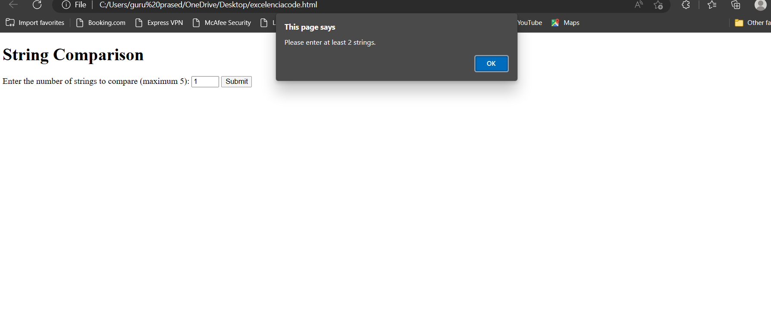step2: if input is between 2 to 5

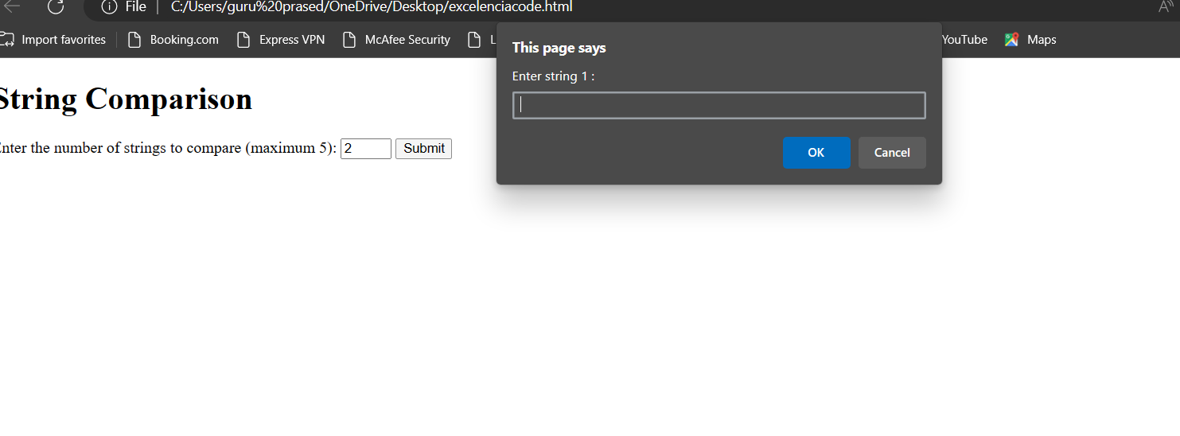

Step3: vowels comparison and position

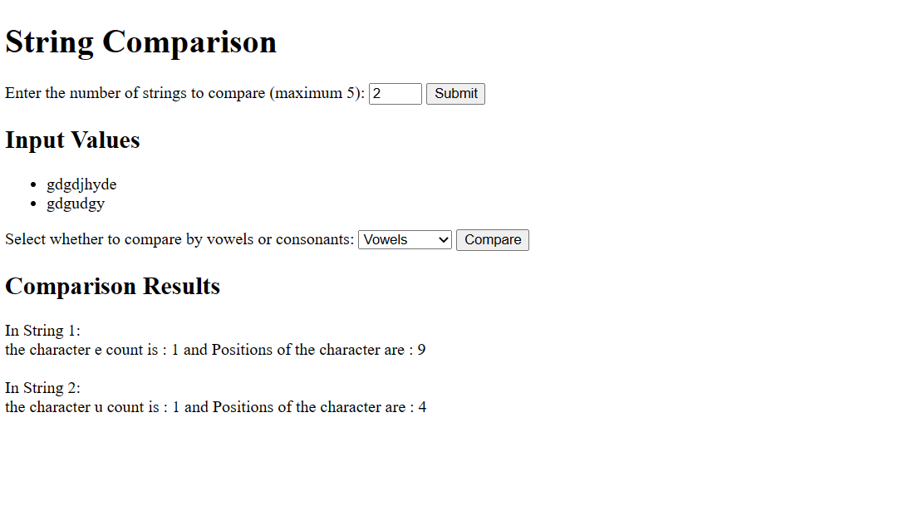

Step4: consonants comparison and position

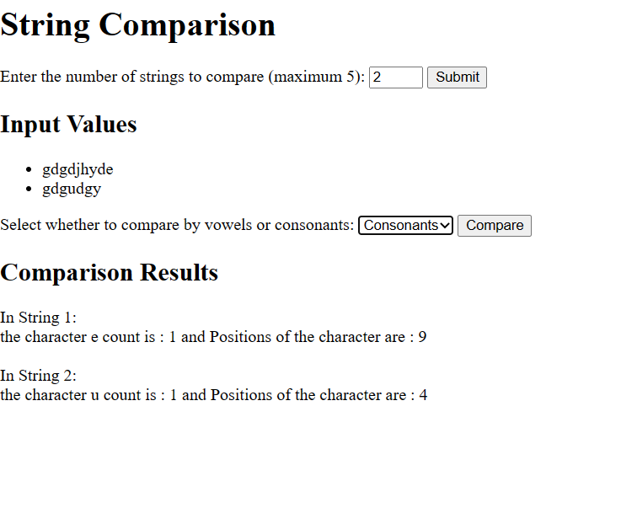

Step5: if input is 6

